Project Report

Probabilistic Graphical Model

03/01/2015

N-most probable configurations

Master MVA

Authors:
Amine ER-RAQABI & Mohamed N'aitN'bark

Introduction
In this project we studied the problem of obtaining the N most likely hidden sequences of HMM given an observable sequence. The Viterbi algorithm is an efficient way to get the first most likely sequence, but to go beyond the first sequence we studied some papers that present an efficient algorithm based on the Max-Product algorithm and a clever partitioning of the feasible space.
Inferring the N-most likely best list of a HMM model has useful applications in handwriting recognition, voice recognition, spell checking, natural language processing,...etc. The common denominator of all these problems is that the HMM model does not capture the totality of the complexity of the data, hence the right answer is not always the best sequence, but rather one of the N-most likely sequences.

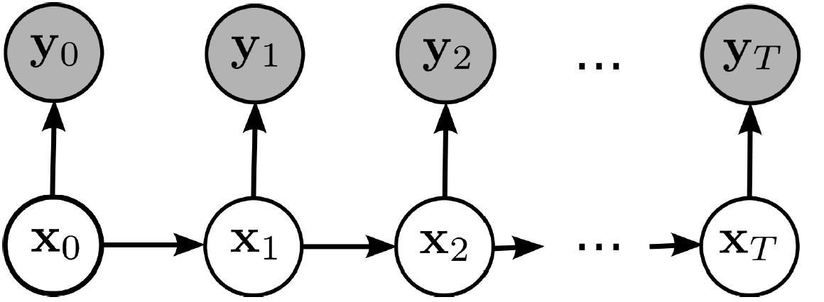

Figure 1: HMM graph

Working on such an interesting project was not with any difficulty. Its common applications being quite complicated to implement, we tried to find an easy application to illustrate the power of this algorithm, and we came up with this simplistic “spell checker” that recovers removed accents from a French word.

Application
The problem that we are interested in in this project is the following:

Given a non accented word in French, how to retrieve the N- most likely (correct) spellings (with accents) in the French language?
Example: “médecin” The output
- Médecin
- Medécin
- Mêdecin

The input
N-Best List Algo
Medecin

Figure 2: Example of the described application

We can see in the example that the “correct” word does not appear at the first place. Indeed all depends on the quality of the database used, but also on the model used. An HMM model takes only bi-grammes into consideration - as it will be mentioned latter in this report. Hence finding the N most likely “corrections” allows to somehow compensate for the limits of the model.

I- HMM parameters estimation:
We consider modeling the French words as Markov Chains, and we suppose that we observe the words without the accents. The parameters of our model are: the initial distribution, the transition matrix and the emission matrix.

Transition Matrix:
We derived the transition matrix from a database of liguistic statistics, particularly on a section that presents the counts of all the bi-grammes found in a set of different text sources (news-papers, books, novels … etc).
The transition matrix is then derived by using a matrix representation of the bi-grammes table: the lines are labeled by the first letter and the columns by the second. Then we just scale the lines.

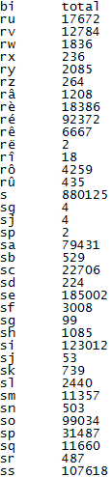

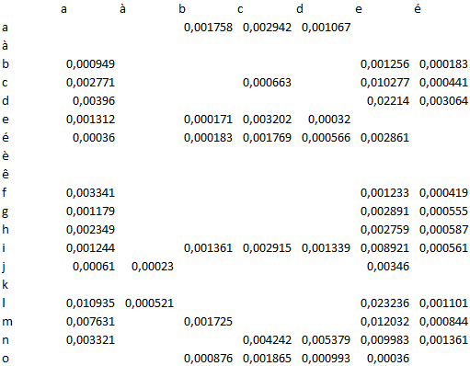

The possible states of the hidden variables are all the possible letters in the French Language (accented or not ) :

Space + a à â b c d e é è ê ë f g h i î ï j k l m n o ô p q r s t u ù û v w x y z

Emission Matrix:

The emission matrix models in our application the process of removing the accents, hence we construct it as the following:

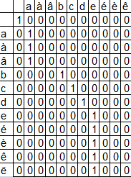

- A non-accented letter would give with a probability 1 the same non accented letter ( i.e. the case of the letter « a »).
- An accented letter give with a probability 1 its non-accented version ( i.e. the case of the letter « é » giving with probability 1 of observing « e » ).

Initial distribution vector

This vector is formed of the probabilities of observing the first letter of a word, which means the probabilities of the bi-grammes:

[ SPACE – X ] where X is any letter of the considered alphabet.

II-The algorithm description

III-Test & Results

We implemented the described algorithm on the our model and we ran some tests to assess the performance of our application:

- universite
 | Combinations | Probabilities
The best | universite | 4.1887e-14
The second best | université | 8.1839e-15
The third best | univérsite | 1.6587e-18

- antecedent
 | Combinations | Probabilities
The best | antécédent | 8.4538e-14
The second best | antécedent | 7.8419e-14
The third best | antecédent | 6.4538e-14

- fute
 | Combinations | Probabilities
The best | fute | 5.9800e-07
The second best | futé | 1.1684e-07
The third best | fûte | 2.2178e-08

Conclusion
This algorithms works well for several cases, but fails in some particular cases.
Thus a model based on trigrams would be a realistic improvement that worth being investigated but will necessitate a more complex graphical model.

